Motion and Force in a Gravitational Field

Revision Problems 5: Torque and Equilibrium Due: _________________

Name: __________________________________________ (20 marks total)
- We say that objects are more stable if they have a wide base and a low centre of gravity. Explain this using the concept of torque. (3 marks)

__________________________________________________________________________________________________________________________________________________________________________________________________________________________________________________________________________________________________________________________________________________________________________________________________________________________________________________________________________________________________________________________________________________________________
- Label the following diagrams as stable, unstable or neutral. (3 marks)
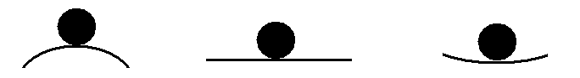
______________________________________________________________________
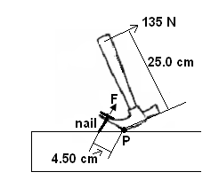
- A claw hammer is be used to remove a nail from a piece of wood as shown. Calculate the pulling force, F, in the situation shown? (2 marks)

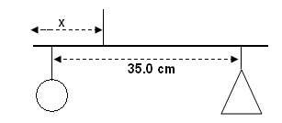

- A child’s mobile has different shapes at each end of a 35.0 cm rod (assume mass of rod is insignificant). The mass of the ball is 60.0 g and the mass of the triangle is 48.0 g. How far from the triangle should the rod be suspended to hang horizontal? (4 marks)

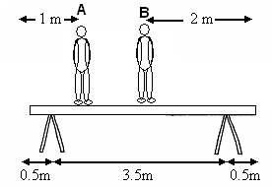
- In order to paint a wall, two men are standing on a supported uniform plank of mass 15.0 kg as shown. (diagram not to scale). Man A, who has a mass of 90.0 kg is 1.00 m from one end while man B, who has a mass of 70.0 kg is 2.00 m from the other end. The supports are 0.500 m from each end of the plank. Calculate how much of the total weight each of the trestle stands supports.
(4 marks)

- A traffic light hangs from a structure as shown. The uniform metal pole AB is 5.50 m long and has a mass of 6.00 kg. The mass of the traffic light is 12.0 kg. Determine the tension in the horizontal cable CD. (Assume the cable has no mass itself.) (4 marks)

